Minutes from Eco Steward Meeting 20.11.23

In attendance:
Our Lady of Walsingham
St Mary’s
St Brendan’s
Thomas Becket
St John Rigby

Schools shared the following that they had been working on in school since our last meeting:

- Poster competition
- Delegating energy monitors to check that things have been switched off in classrooms
- School assembly
- Recycling and repurposing (making poppies)
- Food waste bins – contact Veolia 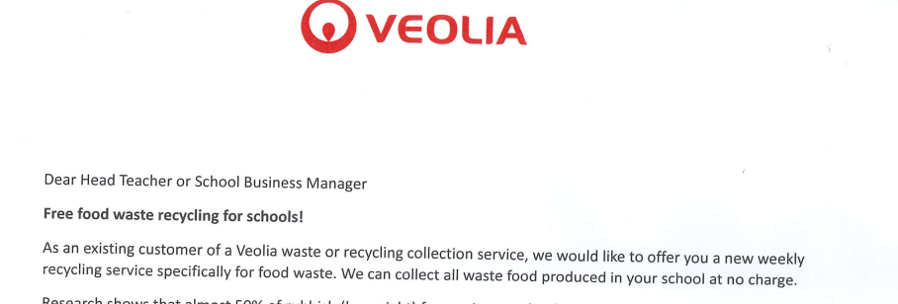
- Signing up to ‘The Big Plastic Count.’
- Sharing ideas for how to save energy and money
- Surveys
- Events to raise money for solar panels Solar Panel Grants For Schools | Apply Now (solar-grants.co.uk) - see below
- Grow more plants

Ideas for sharing the message wider:
Add to the social media pages – send any info to Mrs Meeks
Write a termly newsletter
Hold events for the wider community
Write to MP


