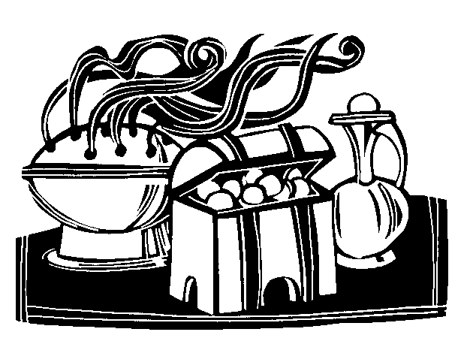

20 + C + M + B + 22

Christus Mansionem Benedicat
May Christ Bless this Home

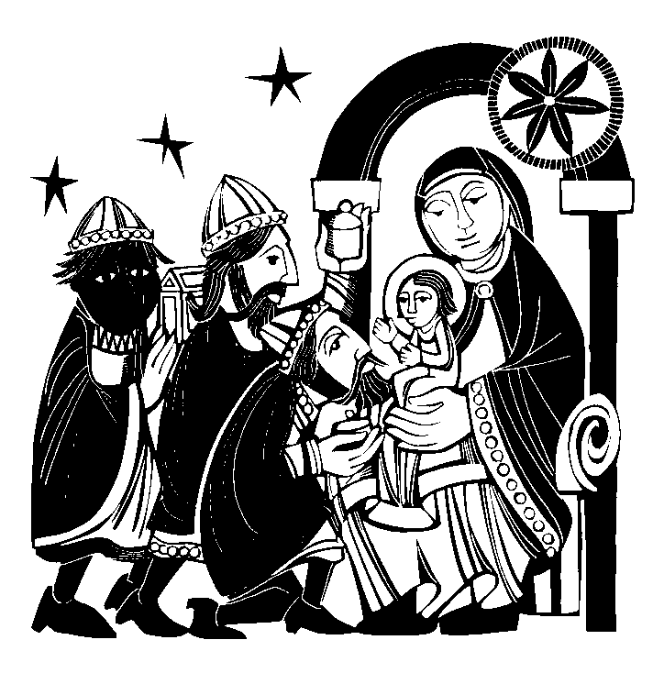

NORES - Diocese of Northampton
Office for RE, Evangelisation, Catechesis & Schools
SUPPORTING CATHOLIC EDUCATION
AND FORMATION

EPIPHANY SCHOOL BLESSING 2022
There is an ancient tradition of blessing Christian homes at Epiphany, asking God’s blessing on all who live in the home in the coming year. Schools can do the same at the main door[s] or for each classroom.
We mark the lintel of the door in chalk with the date, 2022.
We add the initials of the names given to the three wise people
who brought gifts to Jesus in his first home :
- C for Caspar,
- M for Melchior,
- B for Balthasar.
The three initials, C-M-B,
also stand for the three words of a Latin prayer
– Christus Mansionem Benedicat = May Christ bless this house -
If you cannot use chalk on the door/lintel use the opposite side as a sign on the door as well as the blessed chalk we talk about below.

A Blessing Prayer for chalk, water, incense
You can incorporate this into the Prayer service below is you wish,
and use chalk, incense, and water as appropriate.

Blessed are you, Lord God of all creation:
by the guidance of a star you led the magi to your child
and by the light of faith you bring us to know Christ as Lord,
the Messiah you have sent.
[Bless us as we burn this incense,
a sign of the fragrance of prayerful lives offered up before you.]
Bless us as we use this chalk to mark our doors in your honour.
[Bless us as we sprinkle our school/class with this water,
sign of the Lord Jesus’ baptism in the River Jordan.]
May the homes where these things are used in faith
be dwelling places of goodness, humility, self-control,
mutual respect for one another,
hospitality toward strangers,
and loving obedience to your word.
We ask this through Christ our Lord. Amen.

Epiphany is also a time for baptism of infants, It reminds us of our own baptism, which is why it is a good idea to have a holy water font at different places within the school to keep this in mind.
A Prayer Service for the Epiphany Blessing

Gather together as a school, year or class at whichever door you use..

Carol
We three Kings of Orient are; bearing gifts we traverse afar,
field and fountain, moor and mountain, following yonder star.
O star of wonder, star of night, star with royal beauty bright,
westward leading, still proceeding guide us to thy perfect light.

Born a King on Bethlehem plain gold I bring to crown him again,
King for ever, ceasing never, over us all to reign.

Frankincense to offer have I, Incense owns a Deity nigh.
Prayer and praising, all are raising, worship him, God most high.
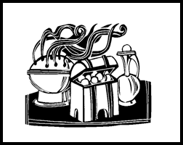
Myrrh is mine, its bitter perfume
breathes a life of gathering gloom;
sorrowing, sighing, bleeding, dying,
sealed in the stone-cold tomb.

Glorious now behold him arise, King and God and sacrifice.
“Alleluia, alleluia!” earth to heaven replies.

Gospel
A reading from the holy Gospel according to Matthew [2:1-12]
We saw his star and have come to do the king homage.
After Jesus had been born at Bethlehem in Judaea during the reign of King Herod, some wise men came to Jerusalem from the east. 'Where is the infant king of the Jews?' they asked. 'We saw his star as it rose and have come to do him homage.' When King Herod heard this he was perturbed, and so was the whole of Jerusalem. He called together all the chief priests and the scribes of the people, and enquired of them where the Christ was to be born. 'At Bethlehem in Judaea,' they told him, 'for this is what the prophet wrote: And you, Bethlehem, in the land of Judah, you are by no means least among the leaders of Judah, for out of you will come a leader who will shepherd my people Israel.' Then Herod summoned the wise men to see him privately. He asked them the exact date on which the star had appeared, and sent them on to Bethlehem. 'Go and find out all about the child,' he said 'and when you have found him, let me know, so that I too may go and do him homage.' Having listened to what the king had to say, they set out. And there in front of them was the star they had seen rising; it went forward and halted over the place where the child was. The sight of the star filled them with delight, and going into the house they saw the child with his mother Mary, and falling to their knees they did him homage. Then, opening their treasures, they offered him gifts of gold and frankincense and myrrh. But they were warned in a dream not to go back to Herod, and returned to their own country by a different way.
The Gospel of the Lord - PRAISE TO YOU, LORD JESUS CHRIST

Mark the door with 20 + C + M + B + 22. Remember that every time you come in you are asking God’s blessing on the life of your school/class in 2020. If you cannot mark the door lintel, perhaps mark the floor and/or put this card up beside or on the door.

Lord God of heaven and earth,
you revealed your only begotten Son to every nation
by the guidance of a star.
Bless this house
and all who inhabit it.
Fill us with the light of Christ,
that our concern for others may reflect your love.
We ask this through Christ our Lord. AMEN

Conclude with the Our Father, or some intercessions.

Carol
And by the light of that same star
three wise man came from country far.
To seek for a king was their intent,
and to follow the star wherever it went
Nowell, nowell, nowell, nowell,
born is the King of Israel.

The star drew nigh to the north-west,
o’er Bethlehem it took its rest,
and there it did both stop and stay
right over the place where Jesus lay.

Then entered in those wise men three
full reverently upon their knee,
and offered there in his presence
their gold and myrrh and frankincense.

